**Tesla’s Global EV Charging Stations: Paving the Way for a Sustainable Future**

As the world transitions towards sustainable energy solutions, one of the leading names in the electric vehicle (EV) revolution is **Tesla**. Beyond manufacturing cutting-edge electric vehicles, Tesla has also invested significantly in a vast network of global EV charging stations. These charging stations are central to Tesla’s mission to accelerate the world’s transition to sustainable energy and are helping to make EV adoption more accessible to the masses.

**The Evolution of Tesla’s Global Charging Infrastructure**

Since its inception, Tesla has been committed to not only creating high-performance electric vehicles but also ensuring that owners have convenient access to charging solutions. In 2012, the company began to roll out its proprietary **Supercharger network**, designed to allow Tesla owners to charge their vehicles quickly and efficiently during long-distance travel.

Over the years, the **Supercharger network** has grown exponentially, from a handful of stations in the United States to a global presence that spans across North America, Europe, Asia, and beyond. Tesla has continuously improved the charging experience with **faster charging speeds**, **solar-powered stations**, and **innovative designs**.

**Tesla Superchargers: The Backbone of the Network**

Tesla’s **Supercharger stations** are the most well-known and widely used component of the company’s global charging infrastructure. These stations provide **high-speed DC fast charging**, which can recharge a Tesla vehicle up to **80% in about 30 minutes**, making long-distance EV travel much more feasible.

Supercharger stations are strategically located along highways and in urban areas to ensure that Tesla owners can easily access charging points when needed. This network has significantly alleviated one of the primary concerns of EV owners: **range anxiety**. By ensuring that Tesla drivers can easily find a nearby charging station, the company has made it easier for consumers to choose electric vehicles without worrying about running out of power on the road.

**Expanding Access: Tesla’s Charging Stations for All EVs**

Tesla has also been working towards **expanding its charging network** to support **non-Tesla electric vehicles**. While Tesla’s Superchargers were initially exclusive to Tesla models, the company has started opening up its network to other EV brands, particularly in Europe, where non-Tesla electric vehicles can access the Supercharger network via **Tesla’s app**.

This expansion reflects a shift towards making EV charging more **universal** and less dependent on specific manufacturers. By opening up its charging stations, Tesla is helping to create a more inclusive and **interconnected EV ecosystem** that will drive the widespread adoption of electric vehicles globally.

**Solar-Powered Superchargers: A Step Towards Sustainability**

Tesla has not only been expanding the number of Superchargers but also focusing on **sustainability**. Many of its charging stations are **solar-powered**, meaning that the energy used to charge the cars comes from renewable sources. The solar panels installed at these stations reduce the environmental impact of charging, making the entire process more sustainable.

Tesla’s commitment to clean energy extends beyond its cars, and the company is leading the way in integrating **solar power** and **battery storage** into its charging network. These solar-powered stations are often paired with **Powerwall batteries**, which store the excess solar energy and ensure that the station can continue to provide power even when the sun isn’t shining.

**Global Reach: Where Tesla’s Charging Stations Are Located**

Tesla’s charging infrastructure spans the globe, with more than **30,000 Superchargers** deployed across over **3,000 locations** worldwide. Here’s a breakdown of Tesla’s key markets:

* **North America**: Tesla’s Supercharger network covers all major highways and cities, ensuring that drivers in the U.S. and Canada can easily travel long distances in their electric vehicles.
* **Europe**: Tesla has strategically placed charging stations in key cities and along major roadways across Europe. The European expansion includes collaborations with other companies to make charging more accessible for a wider range of EVs.
* **Asia**: Tesla has expanded rapidly in China and Japan, two of the largest EV markets in the world. With a growing network in these regions, Tesla is helping to drive the adoption of electric vehicles in the East.
* **Australia**: Tesla has also made significant strides in Australia, ensuring that drivers in remote areas have access to fast charging options.

**Power BI visual for Tesla’s Global Charging Stations**

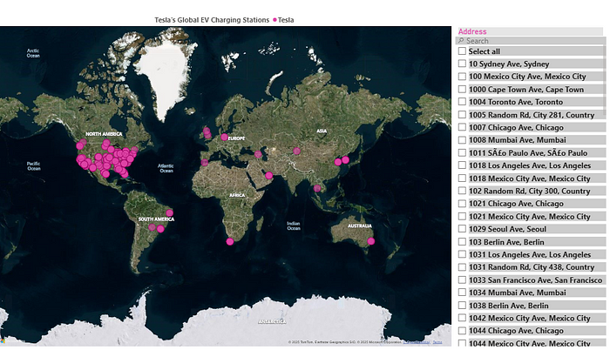

**The Future of Tesla’s Charging Network**

Looking forward, Tesla’s charging infrastructure is set to become even more **powerful** and **accessible**. As the demand for electric vehicles continues to rise, Tesla will need to continue expanding its network of charging stations. The company plans to **accelerate the installation of new Supercharger stations** in both urban and rural areas, and it has committed to making its network compatible with all types of EVs.

Additionally, Tesla is working on improving **charging speeds** with the development of its **next-generation Supercharger V4**, which promises even faster charging times and enhanced efficiency. These innovations will help ensure that Tesla’s global network remains **at the forefront of EV charging technology**.

Tesla’s global network of EV charging stations is a game-changer for the electric vehicle industry. By providing fast, reliable, and sustainable charging options, Tesla is not only ensuring that its own customers have the best experience but is also contributing to the broader transition to sustainable energy. As the world moves towards a more sustainable future, Tesla’s charging infrastructure will play a crucial role in shaping the way we travel and interact with electric vehicles.